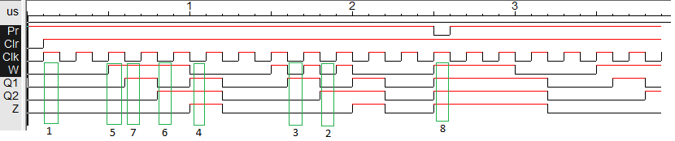For this circuit, we had to test out 8 cases (Cases numbered in the pdf file). Below are the results of a timing analysis of the circuit (Note: upon outside instruction from the professor, I created my own D ff):

The 8 cases are highlighted in the green square. The numbers correspond to the ones in the pdf file of the truth table.